<https://math.stackexchange.com/questions/3228824/inverse-of-a-symmetric-tridiagonal-matrix>

<https://math.stackexchange.com/questions/2413517/inverse-of-the-following-symmetric-tridiagonal-matrix>

<https://en.wikipedia.org/wiki/Tridiagonal_matrix>

<https://www.math.ucsd.edu/~helton/MTNSHISTORY/CONTENTS/2004LEUVEN/CDROM/papers/551.pdf>

Meurand A REVIEW ON THE INVERSE OF SYMMETRIC TRIDIAGONAL

AND BLOCK TRIDIAGONAL MATRICES*

Raf Vandebril, Marc van Van Barel, Nicola Mastronardi - Matrix Computations and Semiseparable Matrices_ Eigenvalue and Singular Value Methods (Volume 2)-The Johns Hopkins University Press (2008)

Inversion <https://en.wikipedia.org/wiki/Tridiagonal_matrix#Inversion> => reduce considerably the problem (or Fonseca, Explicit inverses of some tridiagonal matrices)

Important <https://math.stackexchange.com/a/3231139/195378>

The determinant $\det{Σ}=\prod_{i}{a_{i}}$

Largest eigenvalue of tridiagonal matrix <https://math.stackexchange.com/q/2377802/195378>

Any symmetric matrix can be [brought to tridiagonal form](https://en.wikipedia.org/wiki/Householder_transformation" \l "Tridiagonalization) through finitely many explicit steps

The LU decomposition can be computed easily with (Kilic, 2019, Studying new generalizations of Max-Min matrices with a novel approach)

(Mattila, 2016, Studying the various properties of MIN and MAX matrices-elementary vs. more advanced methods) -> beautiful result

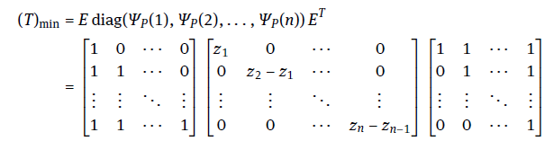

The inversion matrix of E

